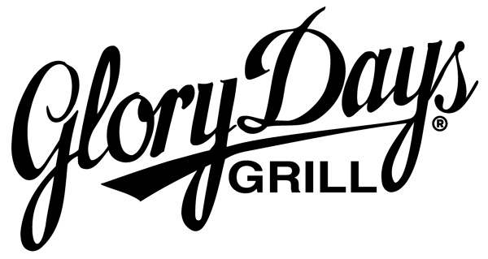

Brunswick Volunteer Ambulance and Rescue Company
Dining for Dollars Fundraiser

WHAT: A Great-Tasting Fundraising Event!

WHEN: August 1st – October 31, 2017

WHERE: Glory Days Grill in Frederick

WHY: When you dine at a Glory Days Grill on your designated nights, we will contribute 10% of the food and beverages purchased to Brunswick Volunteer Ambulance and Rescue Company. Bring your friends, family and neighbors! Simply ask your server for the itemized copy of your guest check (not the charge card receipt), and mail it to: Michele Dilling 200 West Potomac Street; Brunswick, MD 21716
Questions? Call Michele @ 240-409-4114

www.GloryDaysGrill.com

The 10% donation will not apply to guest checks that receive any coupon-specific discount or promotional certificate,
nor will it apply to sales tax. See Dining for Dollars Rules for full details.
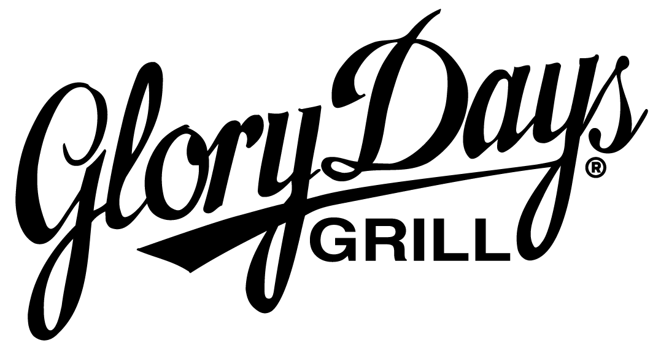

DINING FOR DOLLARS
Submission Form

Name of Organization | Brunswick Volunteer Ambulance and Rescue Company
Contact Name
Contact Phone Number
Contact E-Mail Address
Mailing Address for check
City
State, Zip
Glory Days Grill Locations included
Time Period | August 1st – October 31, 2017
Tax ID Number
Check will be payable to:

Please mail this form with your receipts to:

Glory Days Grill
Attn: Dining for Dollars
9426 Stewartown Road, 2E
Gaithersburg, MD 20879

Please allow 8 weeks to receive your check.

